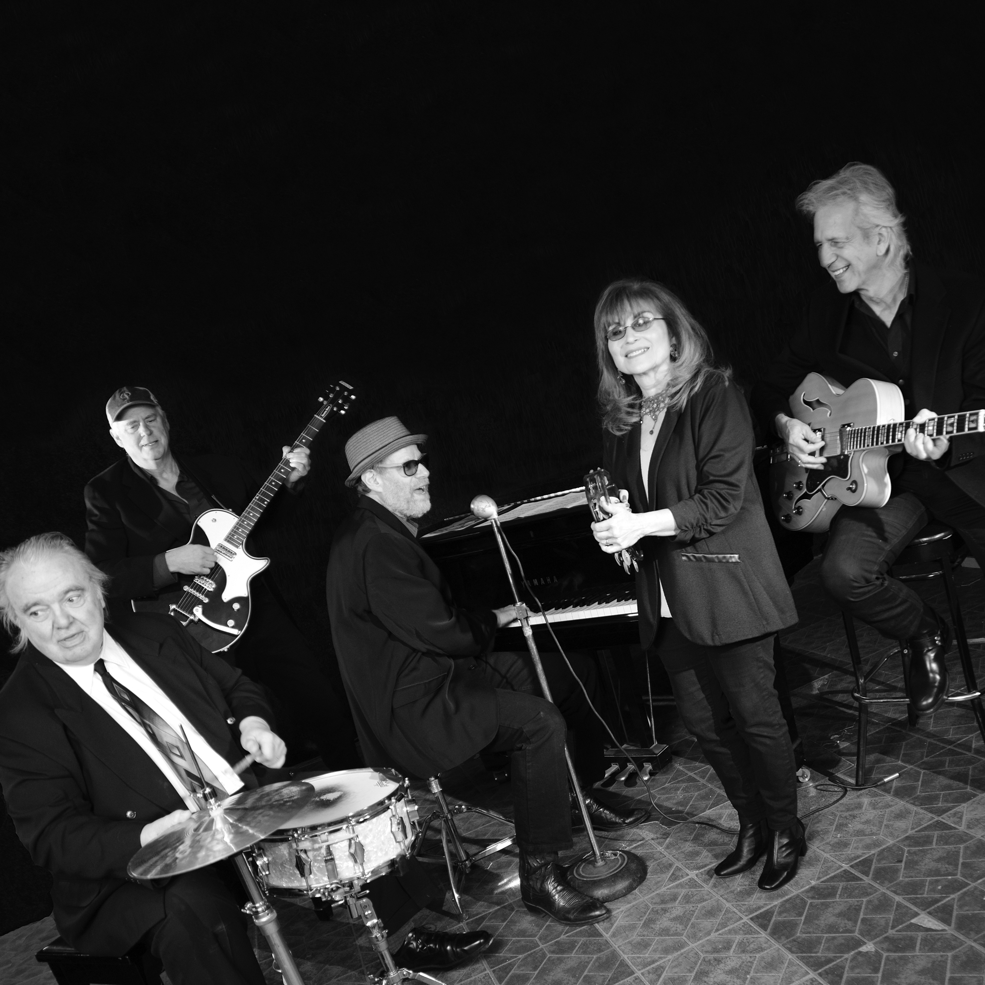

PROFESSOR LOUIE & THE CROWMATIX

Professor Louie & The Crowmatix began as the studio backing band for Aaron “Professor Louie’s” musical productions for the Rock and Roll Hall of Fame Inductees, The Band. Rick Danko christened him Professor Louie due to his work and friendship with The Band.

This GRAMMY-nominated Woodstock, NY group plays 150 shows a year in the US and worldwide. They have performed at the Thunder Bay, London, Windsor, Tondor, Falcon Ridge Festivals, Sellersville Theater, BB Kings, NYC, House Of Blues, LA. Professor Louie has performed twice on The Legendary Rhythm & Blues Cruise.

Professor Louie & The Crowmatix repertoire is steeped in rock ‘n’ roll, blues, Gospel and American roots music, they have 12 studio CD’s on The Woodstock Records label. Their latest recording, Crowin' The Blues will be released on Digital & Web
Feb 17 and in stores April 7, 2017. Their CD, Music From Hurley Mountain, was voted best concept record & group by Radio Crystal Blue in 2016. PL & C have been inducted into Blues Hall Of Fame, New York Chapter and hold a permanent place in the Canada South Blues Museum.

“Roots Music Royalty!” Extended Play Sessions - Bill Hurley

Professor Louie (Keys-Accordion,Vocals) collaborated with Rock n Roll Hall Of Fame group The Band for over 16 years. Played and produced their hit Atlantic City.

John Platania (Guitar-Vocals) known for his great performances with Van Morrison for over thirty years and collaborated with Van creating some top hits such as Domino.

Gary Burke (Drums) performed with Bob Dylan’s The Rolling Thunder Review recorded and toured extensively with Joe Jackson.

Miss Marie (Vocals-Percussionist-Keys) preformed, recorded with Levon Helm, Rick Danko, Garth Hudson an integral part of Mercury Rev’s Gold Album Deserters Song.

Frank Campbell (Bass-Vocals) Levon Helm’s music director with the Woodstock All-stars touring the USA, performed & recorded with Steve Forbert on tour.

“I've never been so impressed by a band--this is the best live band in the country right now and they have such a deep heritage in blues and rock and roll.”

Jeff Wignall - WPKN Music Director

“All the best parts of great music are on display with Professor Louie & The Crowmatix. It’s clear these folks are driven to match the all time greats.” - Cash Box

professorlouie.com woodstockrecords.com Blind Raccoon betsie@blindraccoon.com

